**CE MARK AND FDA AUTHORISED**

**World-first daytime therapy that targets the root cause of sleep apnoea and snoring**

**MEDIA CONTACT:**

**JPA Health | signifier@jpa.com**

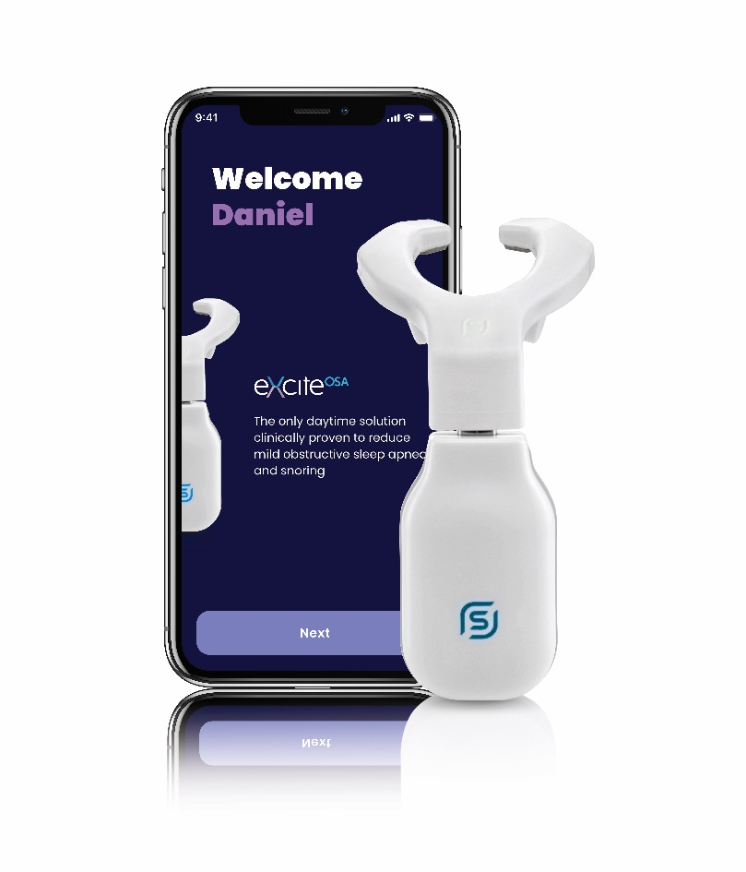eXciteOSA is a revolutionary oral neuromuscular stimulation therapy device for mild obstructive sleep apnoea (OSA) and primary snoring. The device differs from other treatments for these conditions in that it is not a splint to keep the airway open at night; it is intended to be used during the day. It has been shown to be well-tolerated and effective in reducing key indicators of OSA and has been clinically proven to target a key root cause of sleep apnoea and snoring, so that people can regain good quality sleep and a healthier life.1, 2

One of the root causes underlying snoring and OSA is the muscles at the back of the tongue lack endurance, relaxing during sleep and falling back to block the airway. eXciteOSA works by using neuromuscular electrical stimulation to exercise those muscles. The device rests on the tongue and stimulates the pharyngeal and tongue muscles directly with safe, low-frequency impulses to improve their endurance.

Patients using devices such as continuous positive airway pressure (CPAP) and automatic positive airway pressure (APAP), which are used during sleep, have been shown to have poor treatment adherence and even sometimes abandon therapy due to discomfort.3 Unlike these treatments, eXciteOSA is the first device which is used exclusively while awake. The device is paired with a Smartphone or tablet application that helps motivate people to achieve high therapy compliance, allowing people to use it freely while tracking progress and results wherever they go.

**Snoring and Obstructive Sleep Apnoea (OSA)**

Snoring is the most common cause of sleep deprivation, affecting around 42% of people4, with a study estimating that approximately 64% of men and 45% of women suffer from snoring in the UK.5 Nearly 1 billion adults aged 30 to 69 years are estimated to have OSA globally.6

A key reason for OSA and snoring is that the patient’s tongue muscles relax during sleep, causing partial airway collapse and decreasing oxygen intake, which causes the sleeper to stop and start breathing during sleep, often jolting them awake.7

OSA can be a serious medical condition, associated with health problems like high blood pressure and increased risks of heart attack, stroke, or death.8 OSA and snoring do not just affect those suffering from them, but also their partners and family members, which can in turn put a strain on relationships.9 There is a vast unmet therapeutic need in snoring and mild OSA, with up to nine million adults suffering in the UK alone.6

**How does eXciteOSA work?**

The eXciteOSA device - which is controlled by a Smartphone app - rests directly on your tongue. The Smartphone App activates the electrodes in the mouthpiece which stimulate the intrinsic and extrinsic pharyngeal and tongue muscles directly to improve muscle tone and endurance.

The device needs to be used once a day for 20 minutes over a period of six weeks. After the first six weeks, the device only needs to be used twice per week to maintain its effect. This then prevents the tongue muscles from collapsing while sleeping, tackling the root of the problem directly and reducing snoring and OSA.

The device has been designed to treat a wide range of patients with mild OSA, in addition to primary snoring, by building endurance of the weak tongue and surrounding muscles known to be root causes of these conditions.

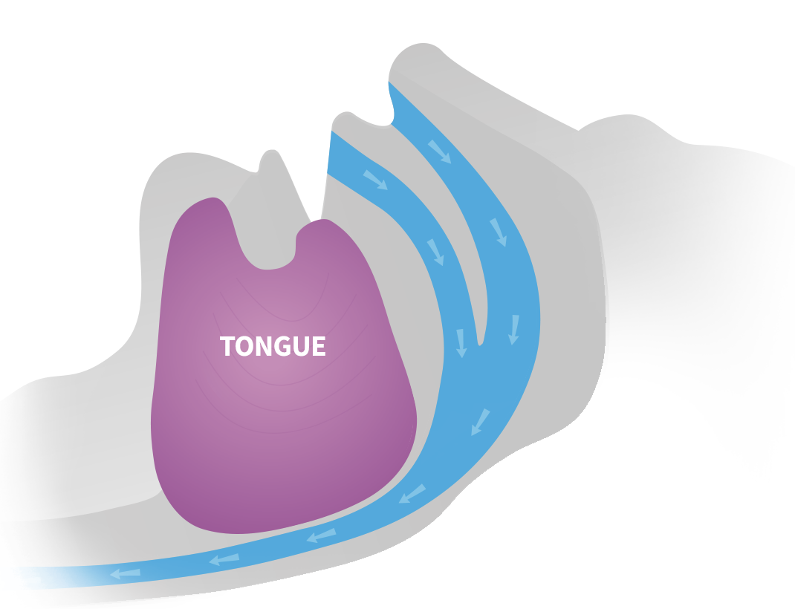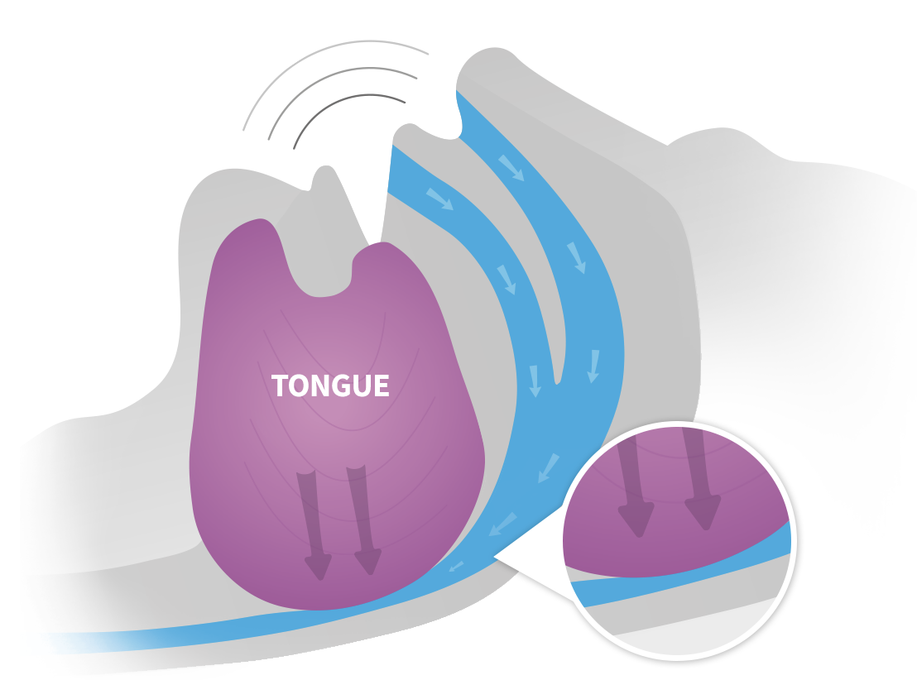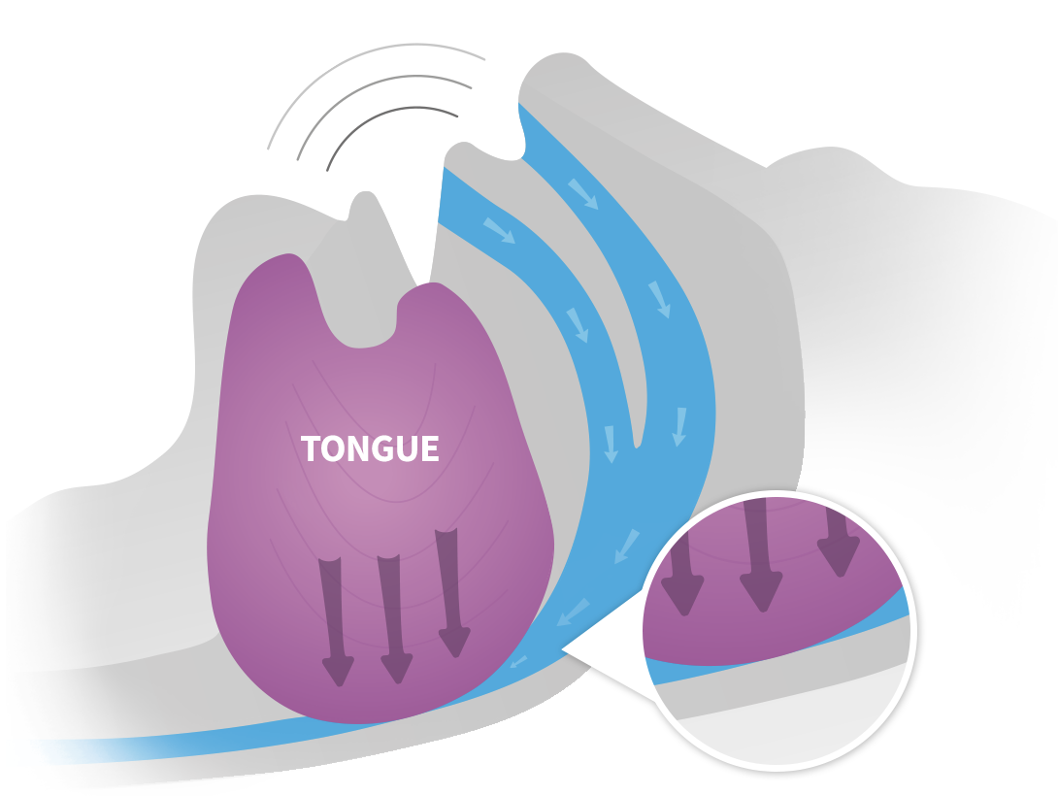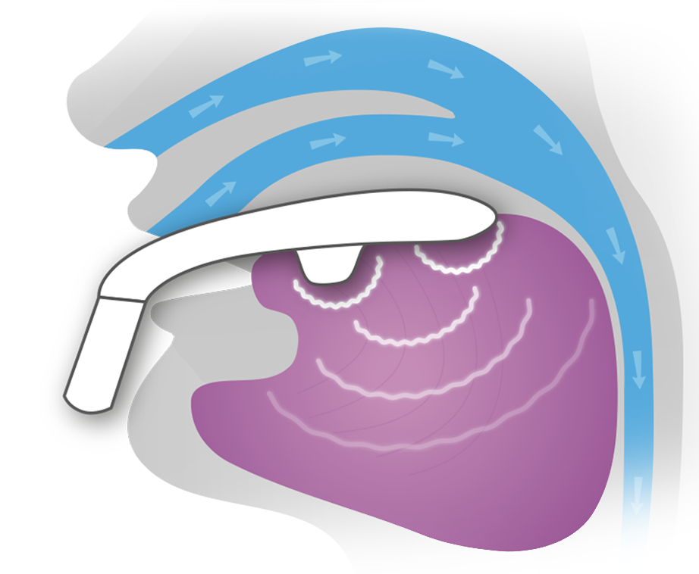

When we sleep tongue muscles relax and fall back in the mouth, partially blocking the airway and resulting in snoring

Snoring often indicates the first stages of sleep apnoea, caused by an obstructed airway interrupting breathing and sleeping

eXciteOSA stimulates tongue muscles, giving them a “workout”, that uniquely targets the root cause of snoring and mild sleep apnoea

Stronger tongue muscles reduce snoring long-term as the tongue no longer blocks the airway at night

**Key Features & Information**

When placed in the mouth, the eXciteOSA device delivers low frequency neuromuscular electrical stimulation (NMES) via four electrodes. The pulses do not 'shock' the tongue, but rather give the muscles of the tongue a 'workout' to strengthen them. This is a well-established physiotherapy approach, such as in leg injury recovery. eXciteOSA is designed to fit comfortably in your mouth so you can get on with other activities while the treatment takes place. The device is rechargeable and has a removable, mouthpiece that can be washed or replaced.

The Smartphone app controls the mouth device, tracks patient progress, and records the results for your healthcare professional to review. Connecting to the device via Bluetooth to activate and customise each therapy session, the app is designed to give personalised care to the patients depending on their usage and motivates them to achieve a high therapy adherence through notifications, session achievements, and bonus points. The app provides personal insights, reports, personalised feedback, and recommendations to both the patient and their healthcare professional.

**Clinical Evidence**

eXciteOSA has gone through rigorous testing and has been approved for use by the EU, Australian TGA, Health Canada and the US FDA. Signifier is also committed to continued data generation and have tested the eXciteOSA device in numerous clinical trials.

The initial clinical trial with eXciteOSA was a multi-centre trial of individuals with snoring and/or mild OSA. The study showed that, on average, bed partners reported a 52% reduction in snoring. This remained stable for two weeks after stopping the therapy suggesting a sustained change in muscle physiology and supporting an improvement in the snorer’s sleep quality with the use of the device.1, 2

In a 2020 European Multi-Centre Trial published in the Journal of Clinical Medicine 10, testing the device on 115 patients, 90% of patients achieved a significant reduction in snoring: an average reduction of 46% in snoring at >40db (which is the same volume as birds chirping or louder), 52% at >45db (the same as normal conversation), and 54% at >50db (loud conversation).

**90% of patients achieved objective reduction in snoring 10**



**46%**

**reduction**in snoring   
at >40db

(Birds Chirping)

**52%**

**reduction**in snoring   
at >45db

(Normal Conversation)

**54% reduction**in snoring  
 at >50db   
(Loud Conversation)

Of those 115, 65 patients suffered from mild OSA, with 79% responding to therapy with a mean reduction of 52% in the Apnoea Hypopnea Index (AHI), a 50% reduction in the Oxygen Desaturation Index (ODI), and a 3.9-point reduction in Epworth Sleepiness Scale (ESS).10

**79% of mild OSA patients responded to therapy 10**



**52% reduction**in Apnoea-Hypopnea Index

**49%**

**reduction**in Oxygen Desaturation Index

**3.9 points reduction**in Epworth Sleepiness Scale

There are also multiple ongoing trials to ensure that we are constantly delivering the best therapy we can to those suffering with obstructive sleep apnoea. These trials are studying the effect of eXciteOSA on patients suffering from mild OSA, patients using APAP therapy, and patients who have failed CPAP/APAP treatment.

**Testimonials**

*Dr. Gurs Sehmi  
Sleep Dentist  
London, UK*

“When I learned about eXciteOSA, I wasn’t sure if I believed it, but I tried it myself, and after a few weeks, my wife noticed a clear difference. What is truly revolutionary is that this device actually strengthens the muscles that go slack and cause snoring. And in addition, my patients do not need to wear anything at night, meaning that they and their partners can get a great quality sleep.”

*Professor Bhik Kotecha  
Consultant Ear, Nose and Throat Surgeon  
Nuffield Health Brentwood Hospital, London, United Kingdom*

“I believe that the eXciteOSA device will play a large role in helping to treat patients with sleep disordered breathing; in particular, those with primary snoring as well as those with mild obstructive sleep apnoea leading to improved sleep quality for both the patient and the partner.”

*Patient Feedback*

“I found it very easy, very comfortable, and I just felt assured that I was going to have a good night sleep. After getting a better night’s sleep, I felt more refreshed in the morning. For me, it made me feel happier and better in myself."

**Further Information**

<https://signifiermedical.com/>

<https://exciteosa.com/>

[2020 Good Design Award for Superior Design Excellence – Press Release](https://signifiermedical.com/2021/03/01/signifier-medical-receives-prestigious-2020-good-design-award-for-superior-design-excellence/)

[FDA Approval – Press Release](https://signifiermedical.com/2021/02/11/signifier-medical-ushers-in-new-era-of-treatment-for-sleep-apnea-and-snoring-with-fda-approval-of-exciteosa-device/)

[Award of UK NHS Supply Chain Tender – Press Release](https://signifiermedical.com/2020/12/22/signifier-medical-technologies-announces-award-of-uk-nhs-supply-chain-tender/)

[IDEA Design Award 2020 – Press Release](https://signifiermedical.com/2020/09/17/signifier-medical-technologies-wins-idea-design-award-2020-for-snoozeal-the-worlds-first-daytime-treatment-device-that-tackles-the-root-cause-of-sleep-disordered-breathing/)

[$10M Series C Funding Round – Press Release](https://signifiermedical.com/2020/09/16/signifier-medical-technologies-closes-10m-series-c-funding-round/)

**References**

1. Wessoleck, E. et al. Intraoral electrical muscle stimulation in the treatment of snoring. Somnologie (Berl). 2018; 22(Suppl 2): 47–52.

2. Sama, A. et al. Daytime Intraoral Neurostimulation with Snoozeal® for treatment of Snoring and Mild Sleep Apnea. CHEST Annual Meeting Notes, 2018.

3. Wolkove N, et al. Long-term compliance with continuous positive airway pressure in patients with obstructive sleep apnea. Can Respir J. 2008;15(7):365-369.

4. Davey, M. J. Epidemiological study of snoring from a random survey of 1075 participant. British Snoring and Sleep Apnoea Association. 2002; Available at: <https://britishsnoring.co.uk/pdf/epidem.pdf>

5. Ohayon M., et al. Snoring and breathing pauses during sleep: telephone interview survey of a United Kingdom population sample. 1997; BMJ314:860–863

6. Benjafield, A. V., Ayas N T, Eastwood P R et al. Estimation of the global prevalence and burden of obstructive sleep apnoea: a literature-based analysis. Lancet Respir Med 2019; 7: 687-698.

7. Levy P, Kohler M, McNicholas WT, et al. Obstructive sleep apnoea syndrome. Nat Rev Dis Primers 2015; 1: 15015.

8. Johnson KG and Johnson DC. Frequency of sleep apnea in stroke and TIA patients: a meta-analysis. J of Clinical Sleep Med 2010;6(2):131-7

9. Luyster FS. Impact of Obstructive Sleep Apnea and Its Treatments on Partners: A Literature Review. J Clin Sleep Med. 2017;13(3):467-477.

10. Baptista PM, Martínez Ruiz de Apodaca P, Carrasco M, et al. Daytime Neuromuscular Electrical Therapy of Tongue Muscles in Improving Snoring in Individuals with Primary Snoring and Mild Obstructive Sleep Apnea. J Clin Med. 2021;10(9):1883.